Task 1: Create a GitHub repo
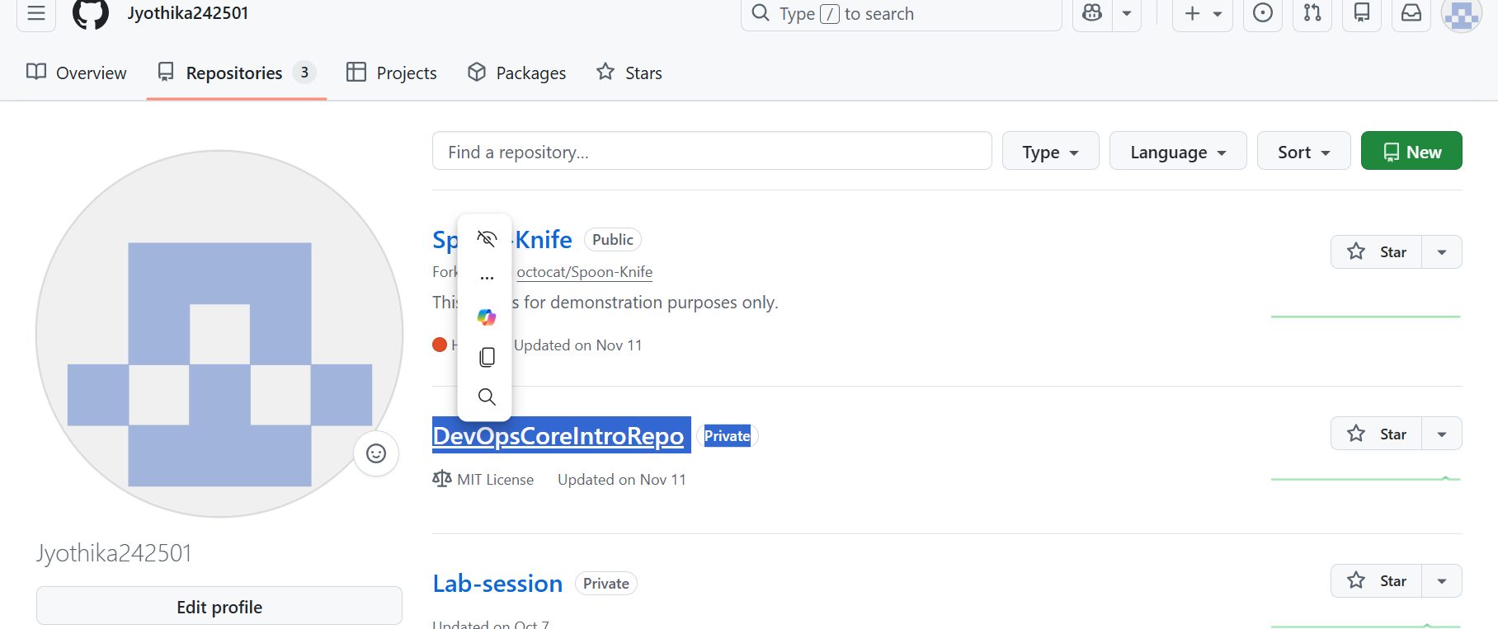

Task 2: Create GitHub milestones and issues
Milestones
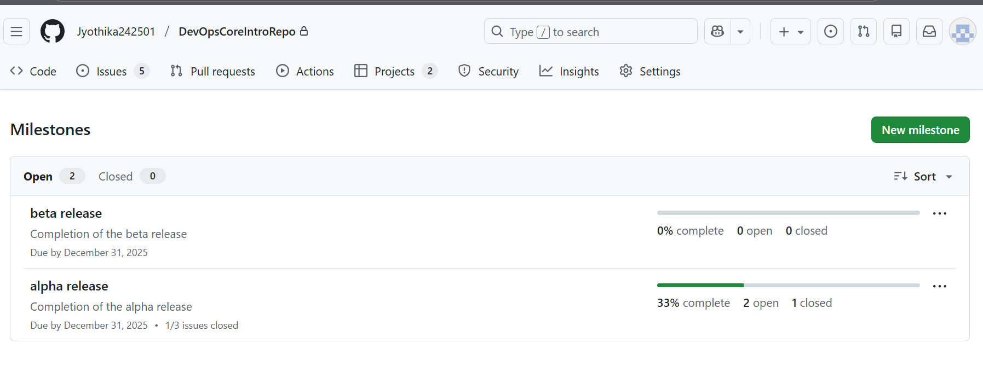
Issues
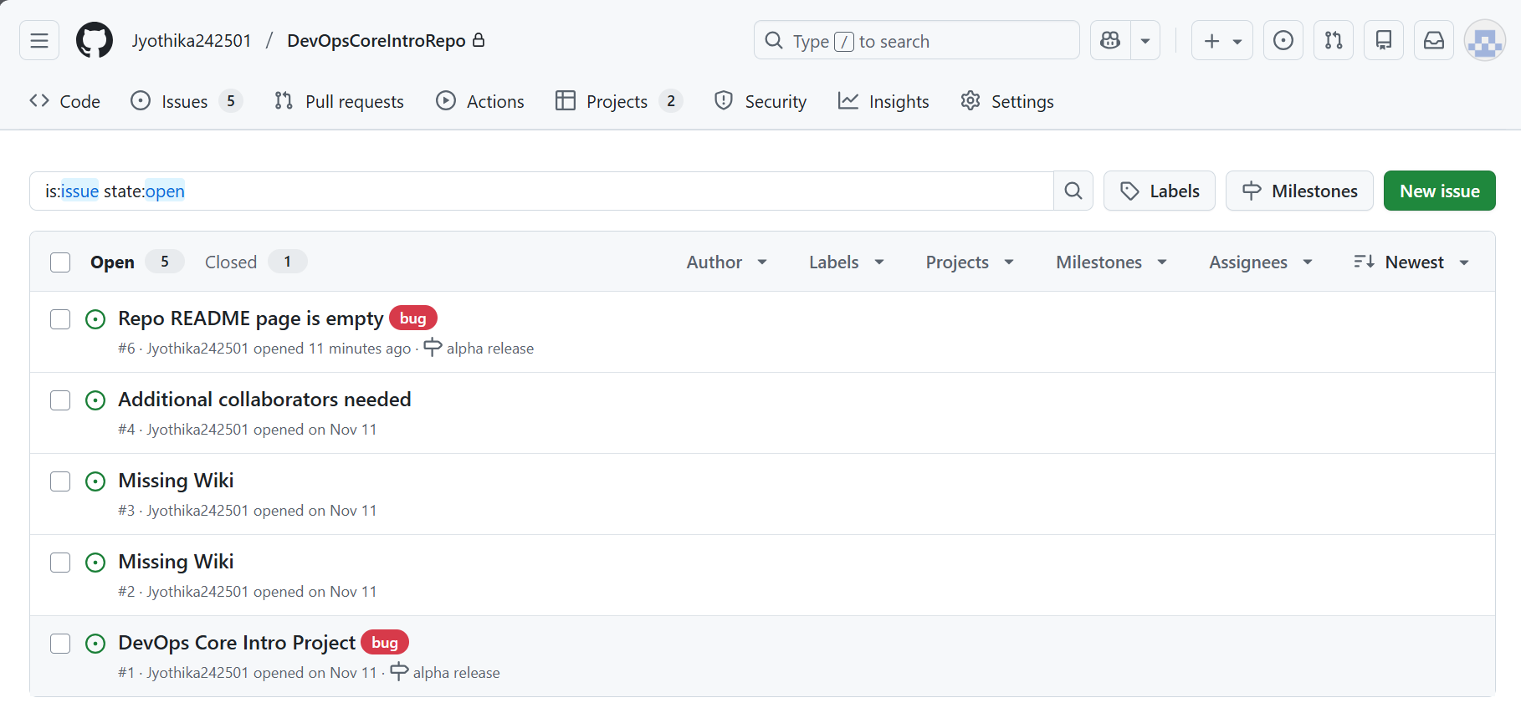
Task 3: Create a GitHub project
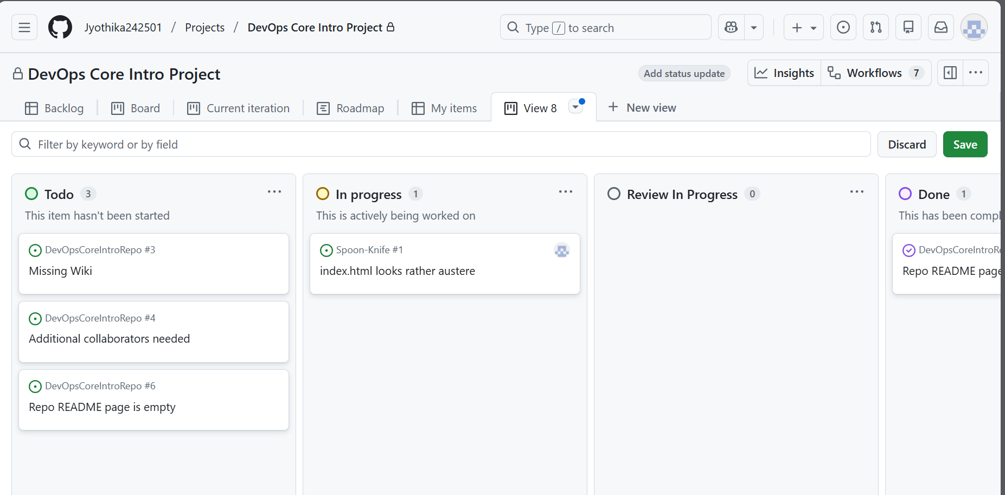

Task 4: Create a GitHub project board
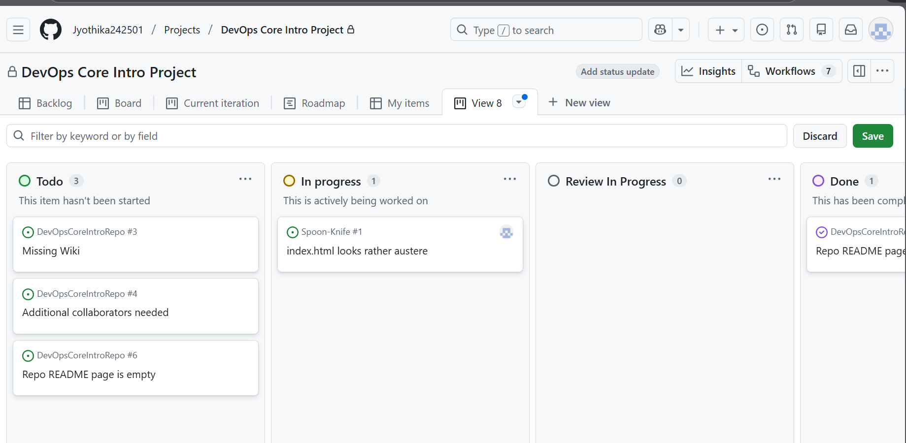

Exercise 2: Create and manage project board items
Task 1: Add a draft item
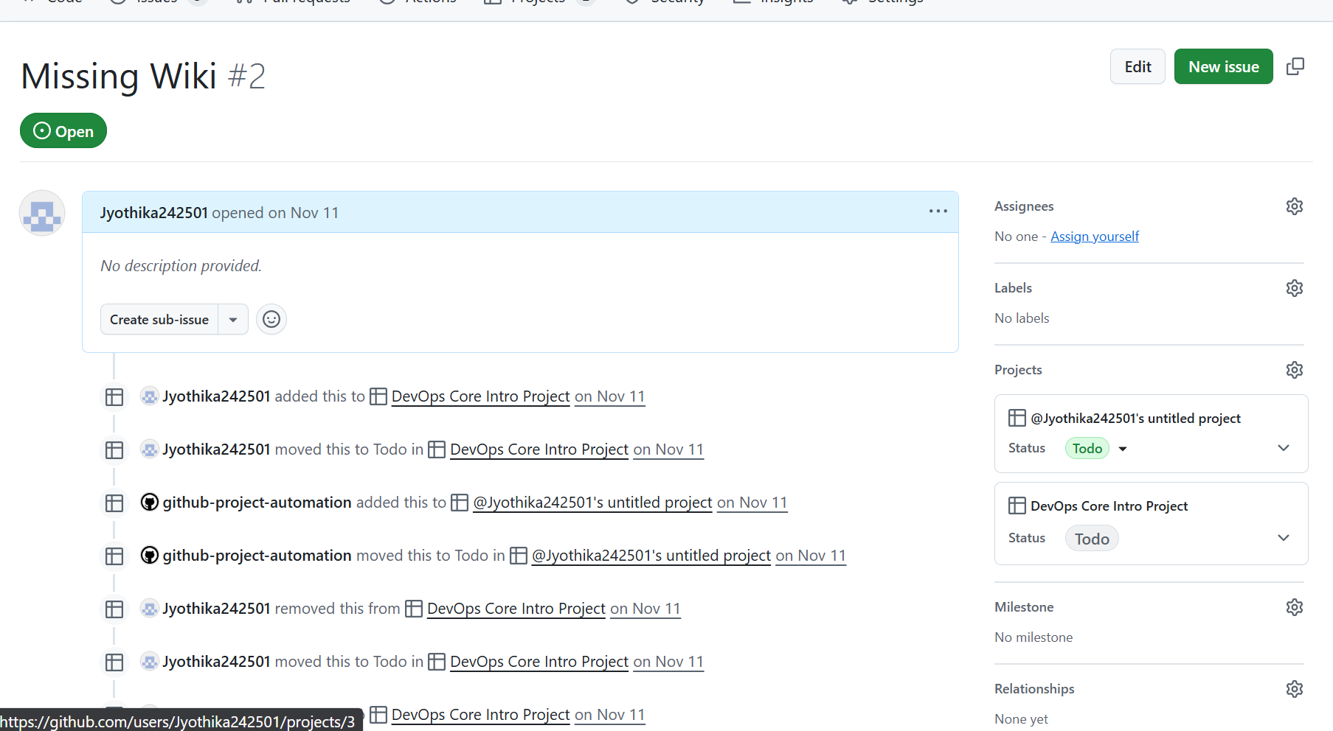

Task 2: Add an item based on an issue
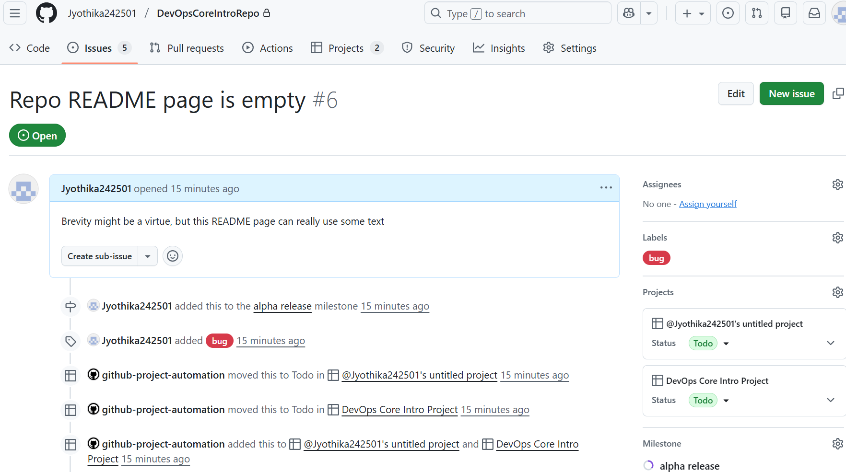
Task 3: Review automation settings
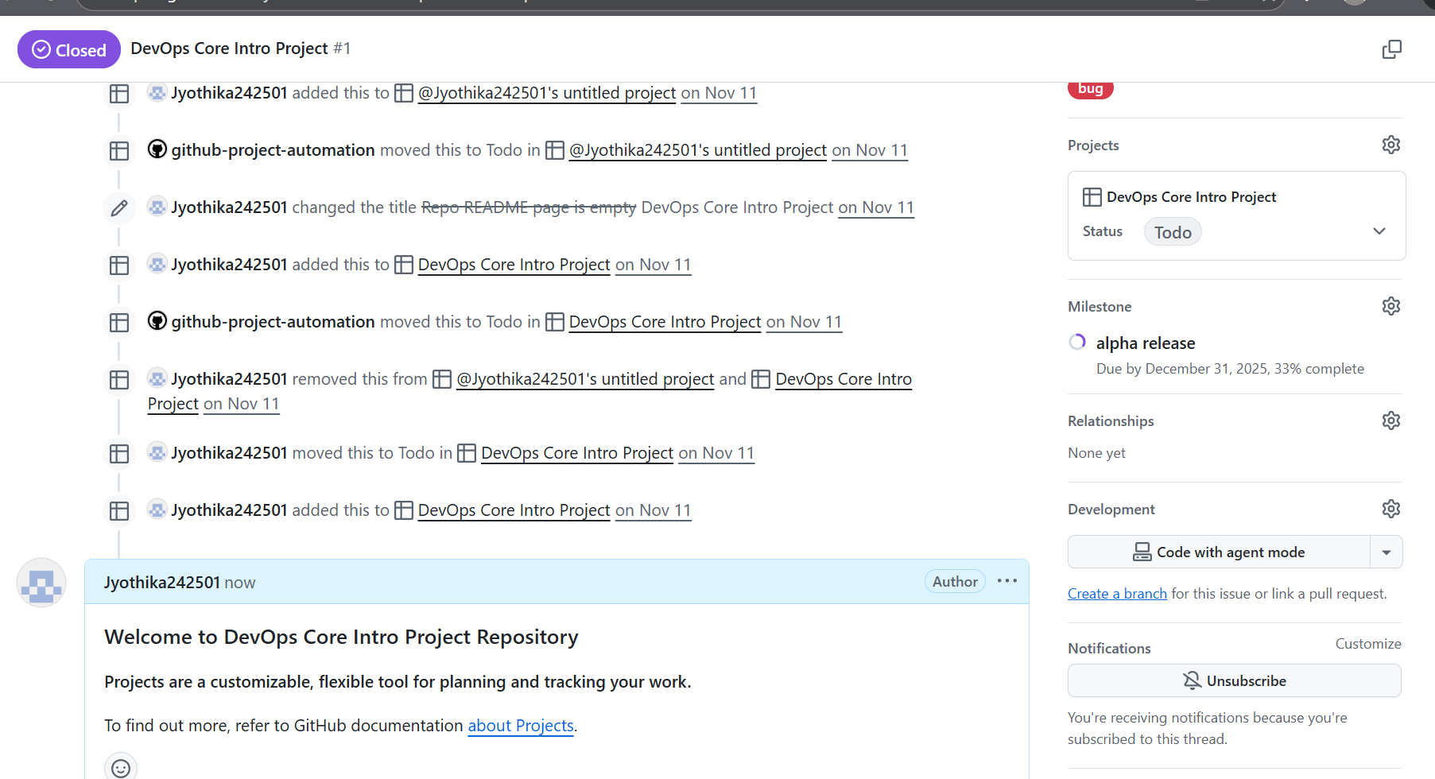

Exercise-2
1: Implement and manage repos with GitHub
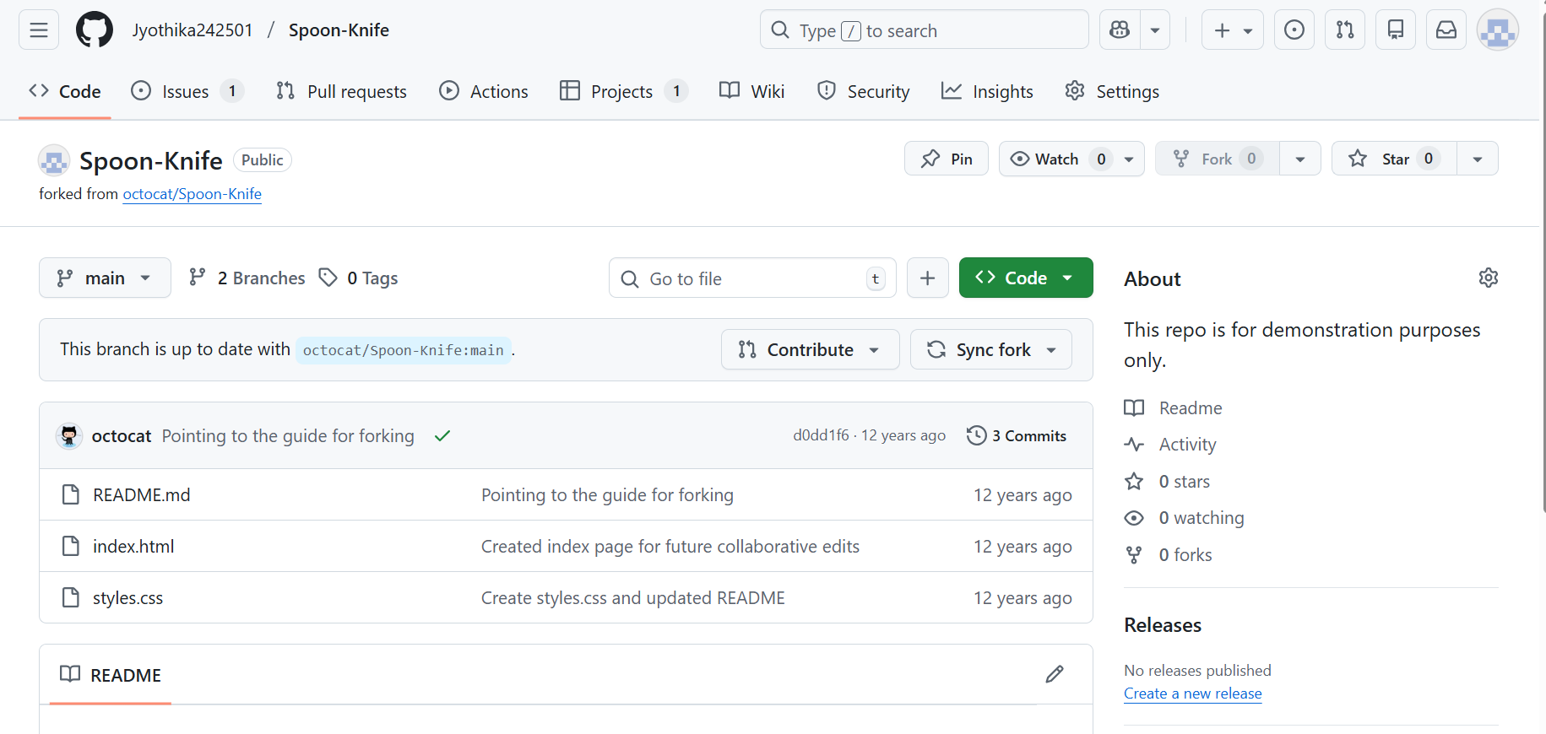

Task 2: Configure a GitHub repo

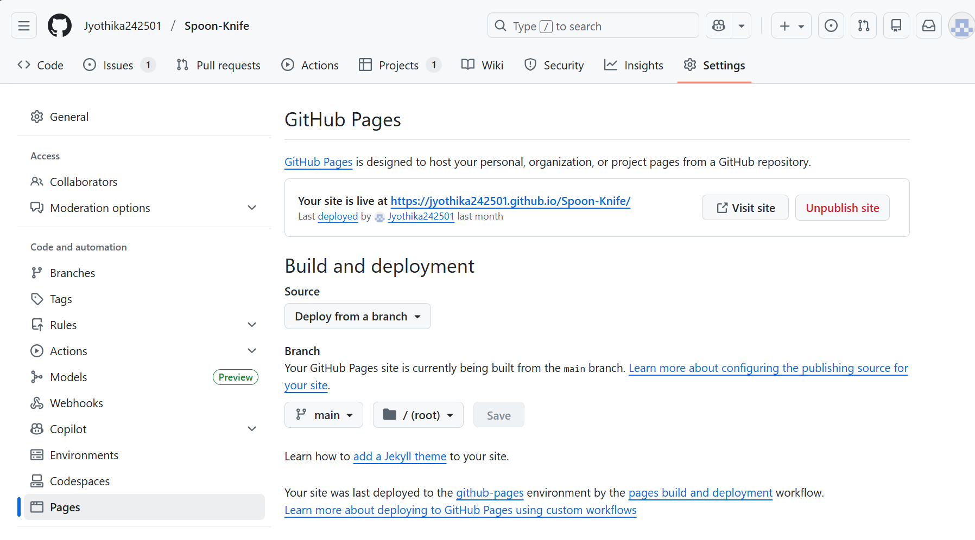

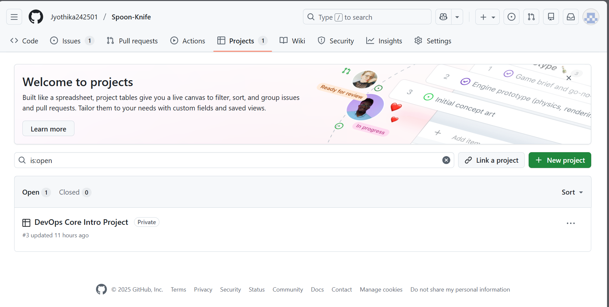

Task 3: Create an issue
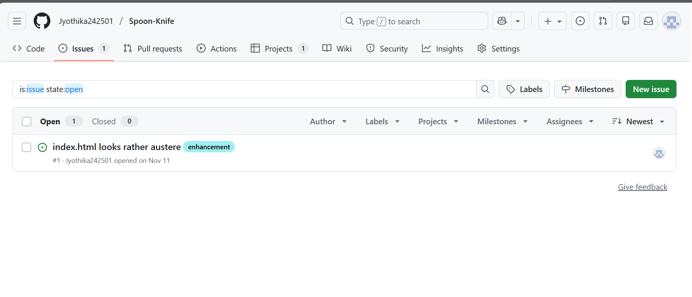
Task 4: Create a branch
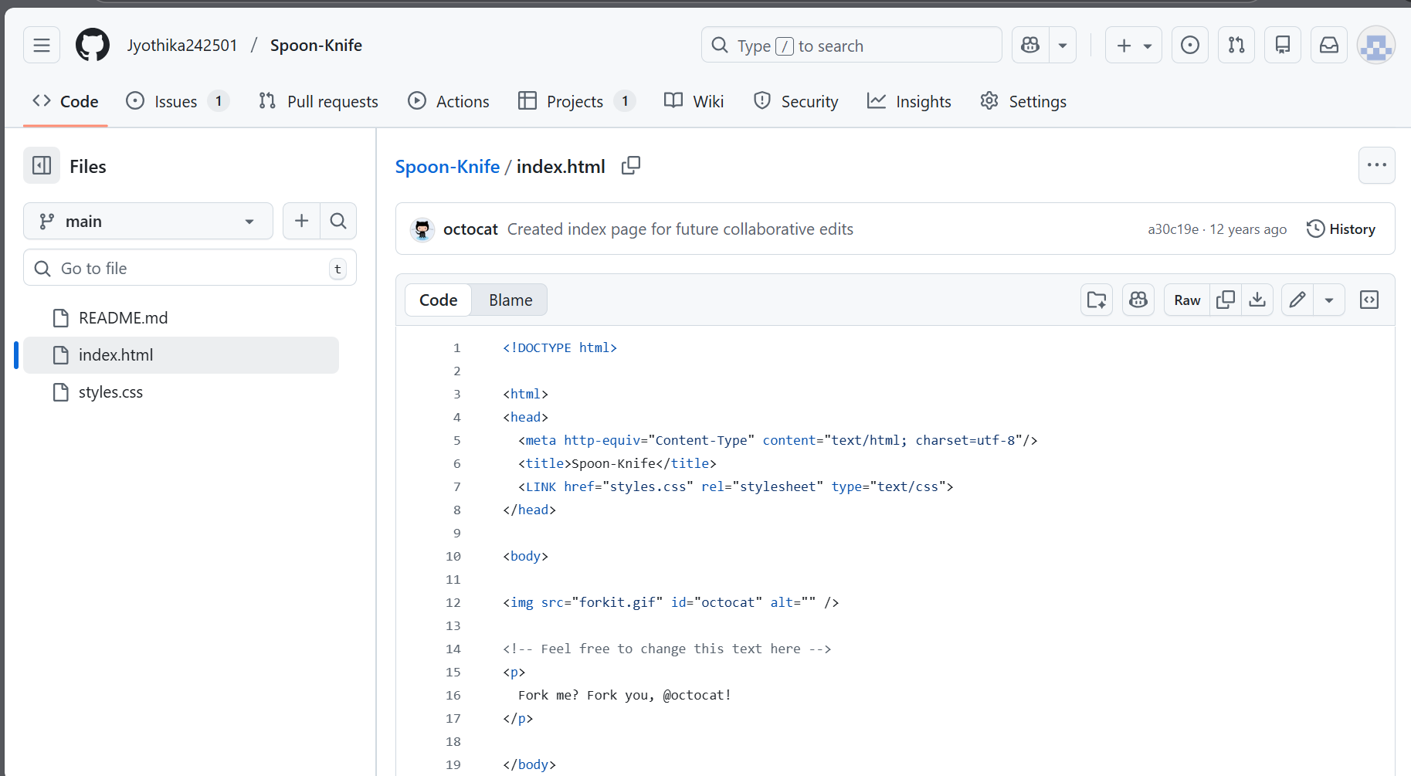

Task 6: Create and merge a pull request
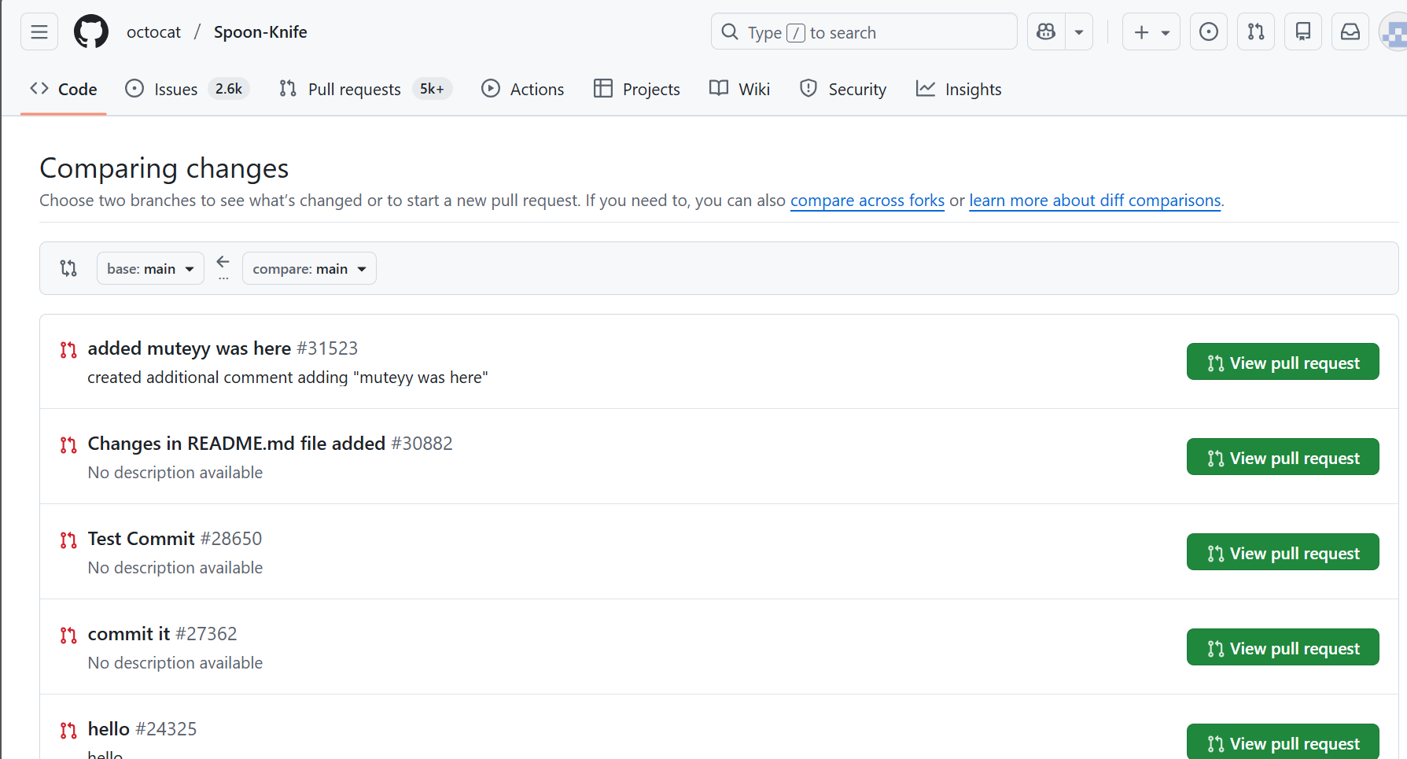

Task 7: Close the issue
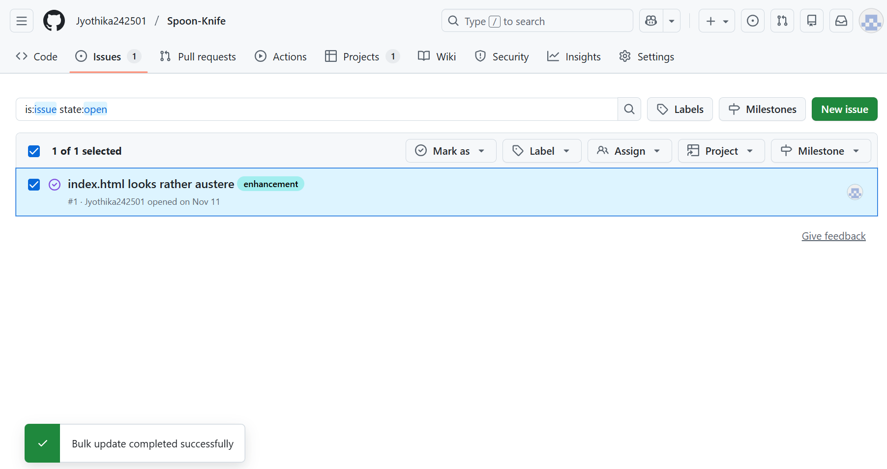
Task 8: Validate the changes
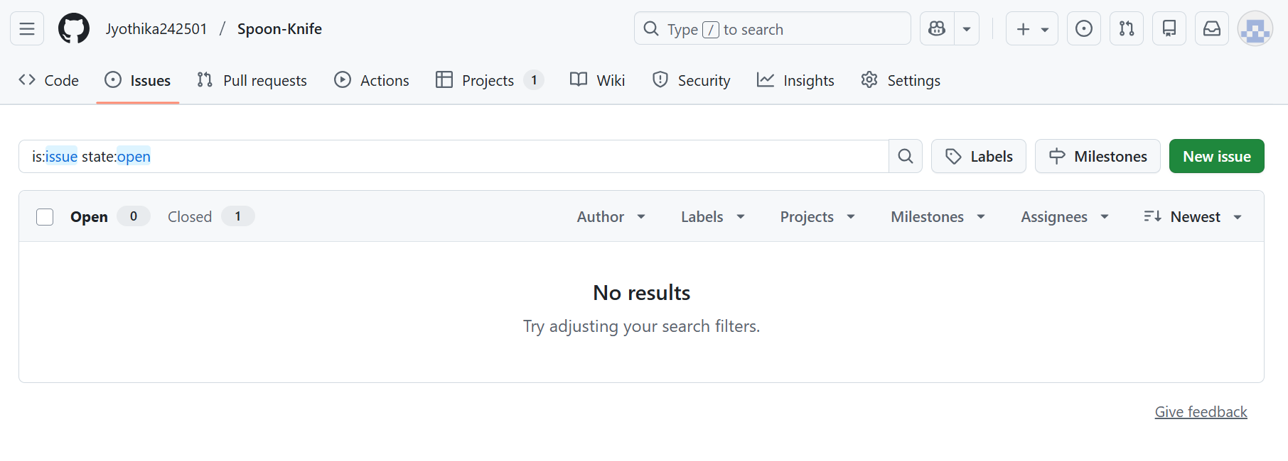

Exercise -3
Task 1: Fork and review the GitHub repo containing the source code of a web app, a GitHub Actions workflow, and a Bicep template

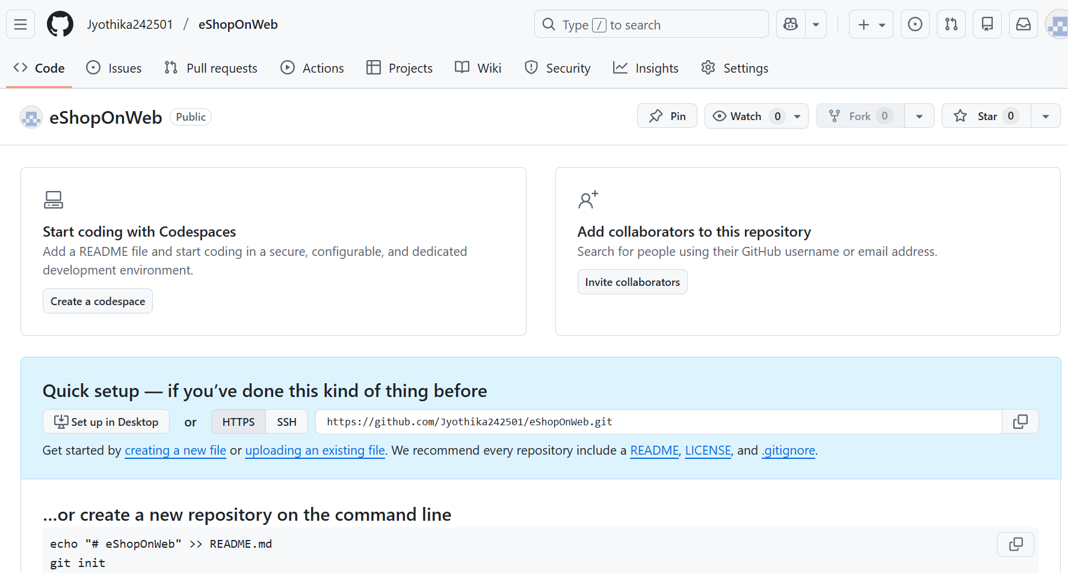
Task 2: Configure the target environment

